**Accessing your School Shared Calendar in a Web Browser**

*This process is a onetime setup to add your School Shared Calendar to OWA.*

1. Sign into <https://portal.office.com/calendar>
2. Click on **Add calendar > From directory**  
     
   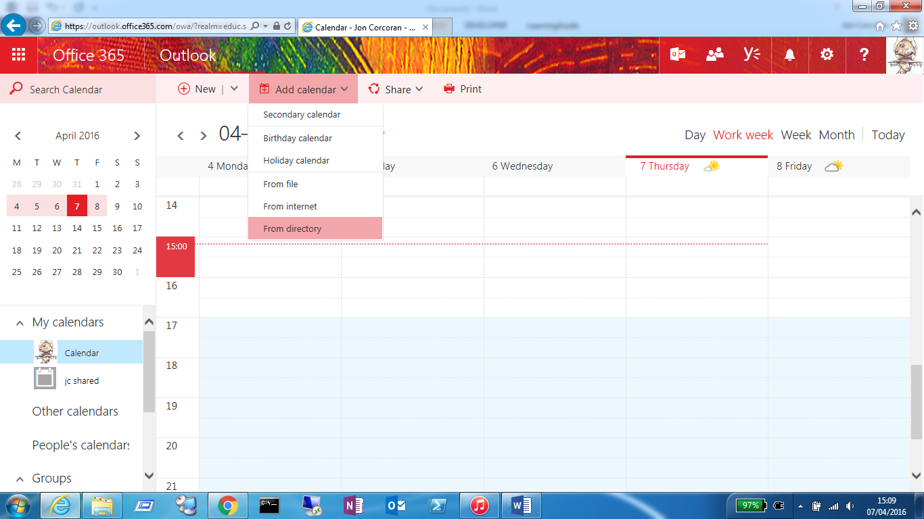  
     
   In the Open Calendar prompt, enter your school’s treasury number followed by Shared Calendar > Then click **Search Directory** > **Open**  
     
   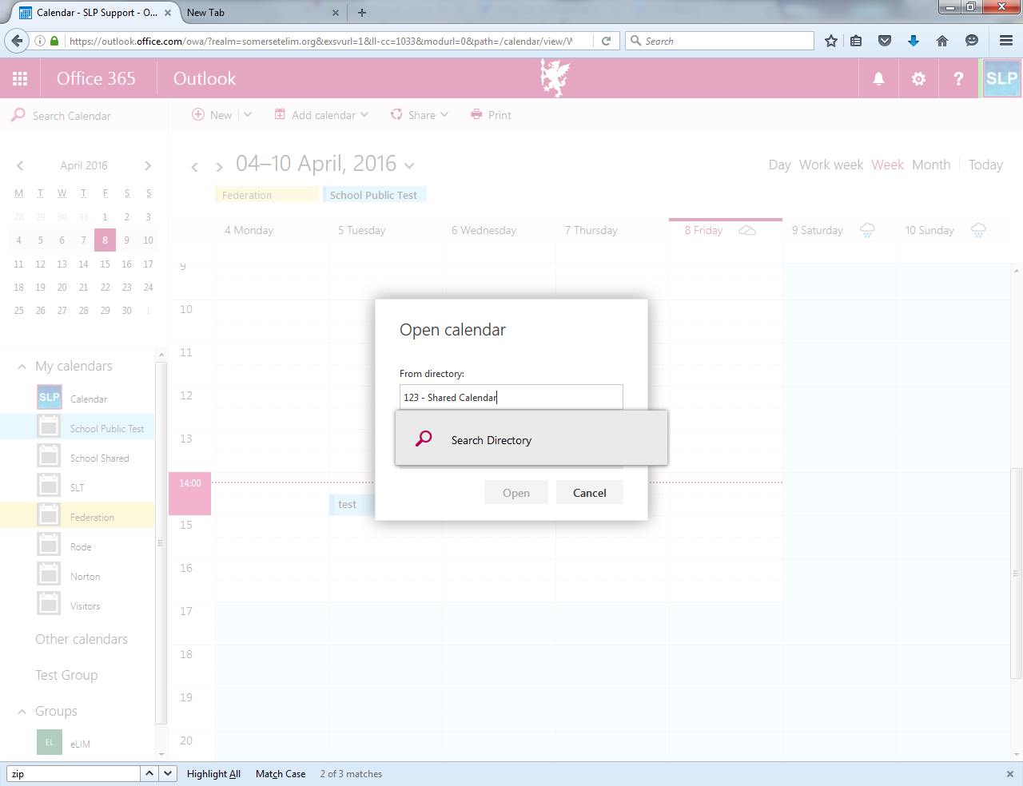
3. Your School Shared Calendar will now always display on the left hand side,   
   under **My Calendars**